**SUBMITTED BY: 1) AYESHA MAJEED (SP22=BSE-008)**

**2) MALAIKA WAHID (SP22-BSE-025)**

**3) MUHAMMAD MUJTABA (SP22-BSE-036)**

**SUBMITTED TO: SIR ATTIQUE AHMED ZAFAR**

SOFTWARE ENGINEERING CONCEPTS

ASSIGNMENT # 2

November 6, 2022

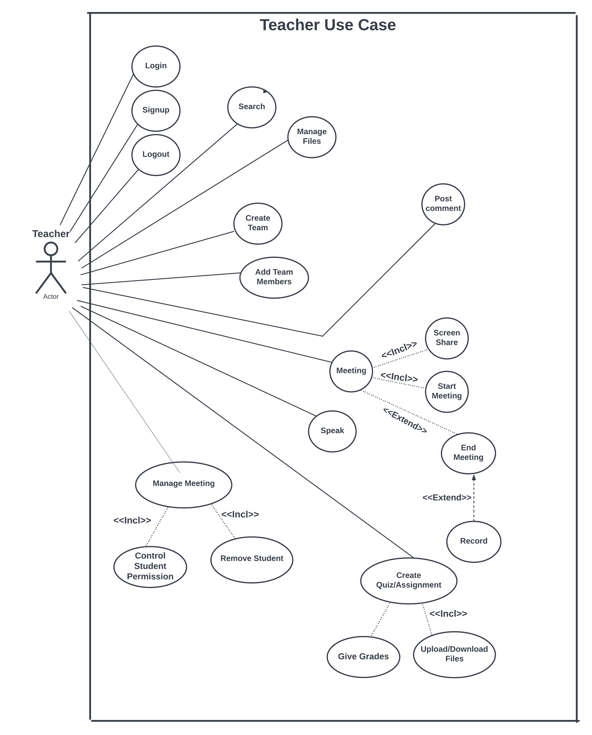**USE CASE DIAGRAM FOR TEACHER-STUDENT RULES:**

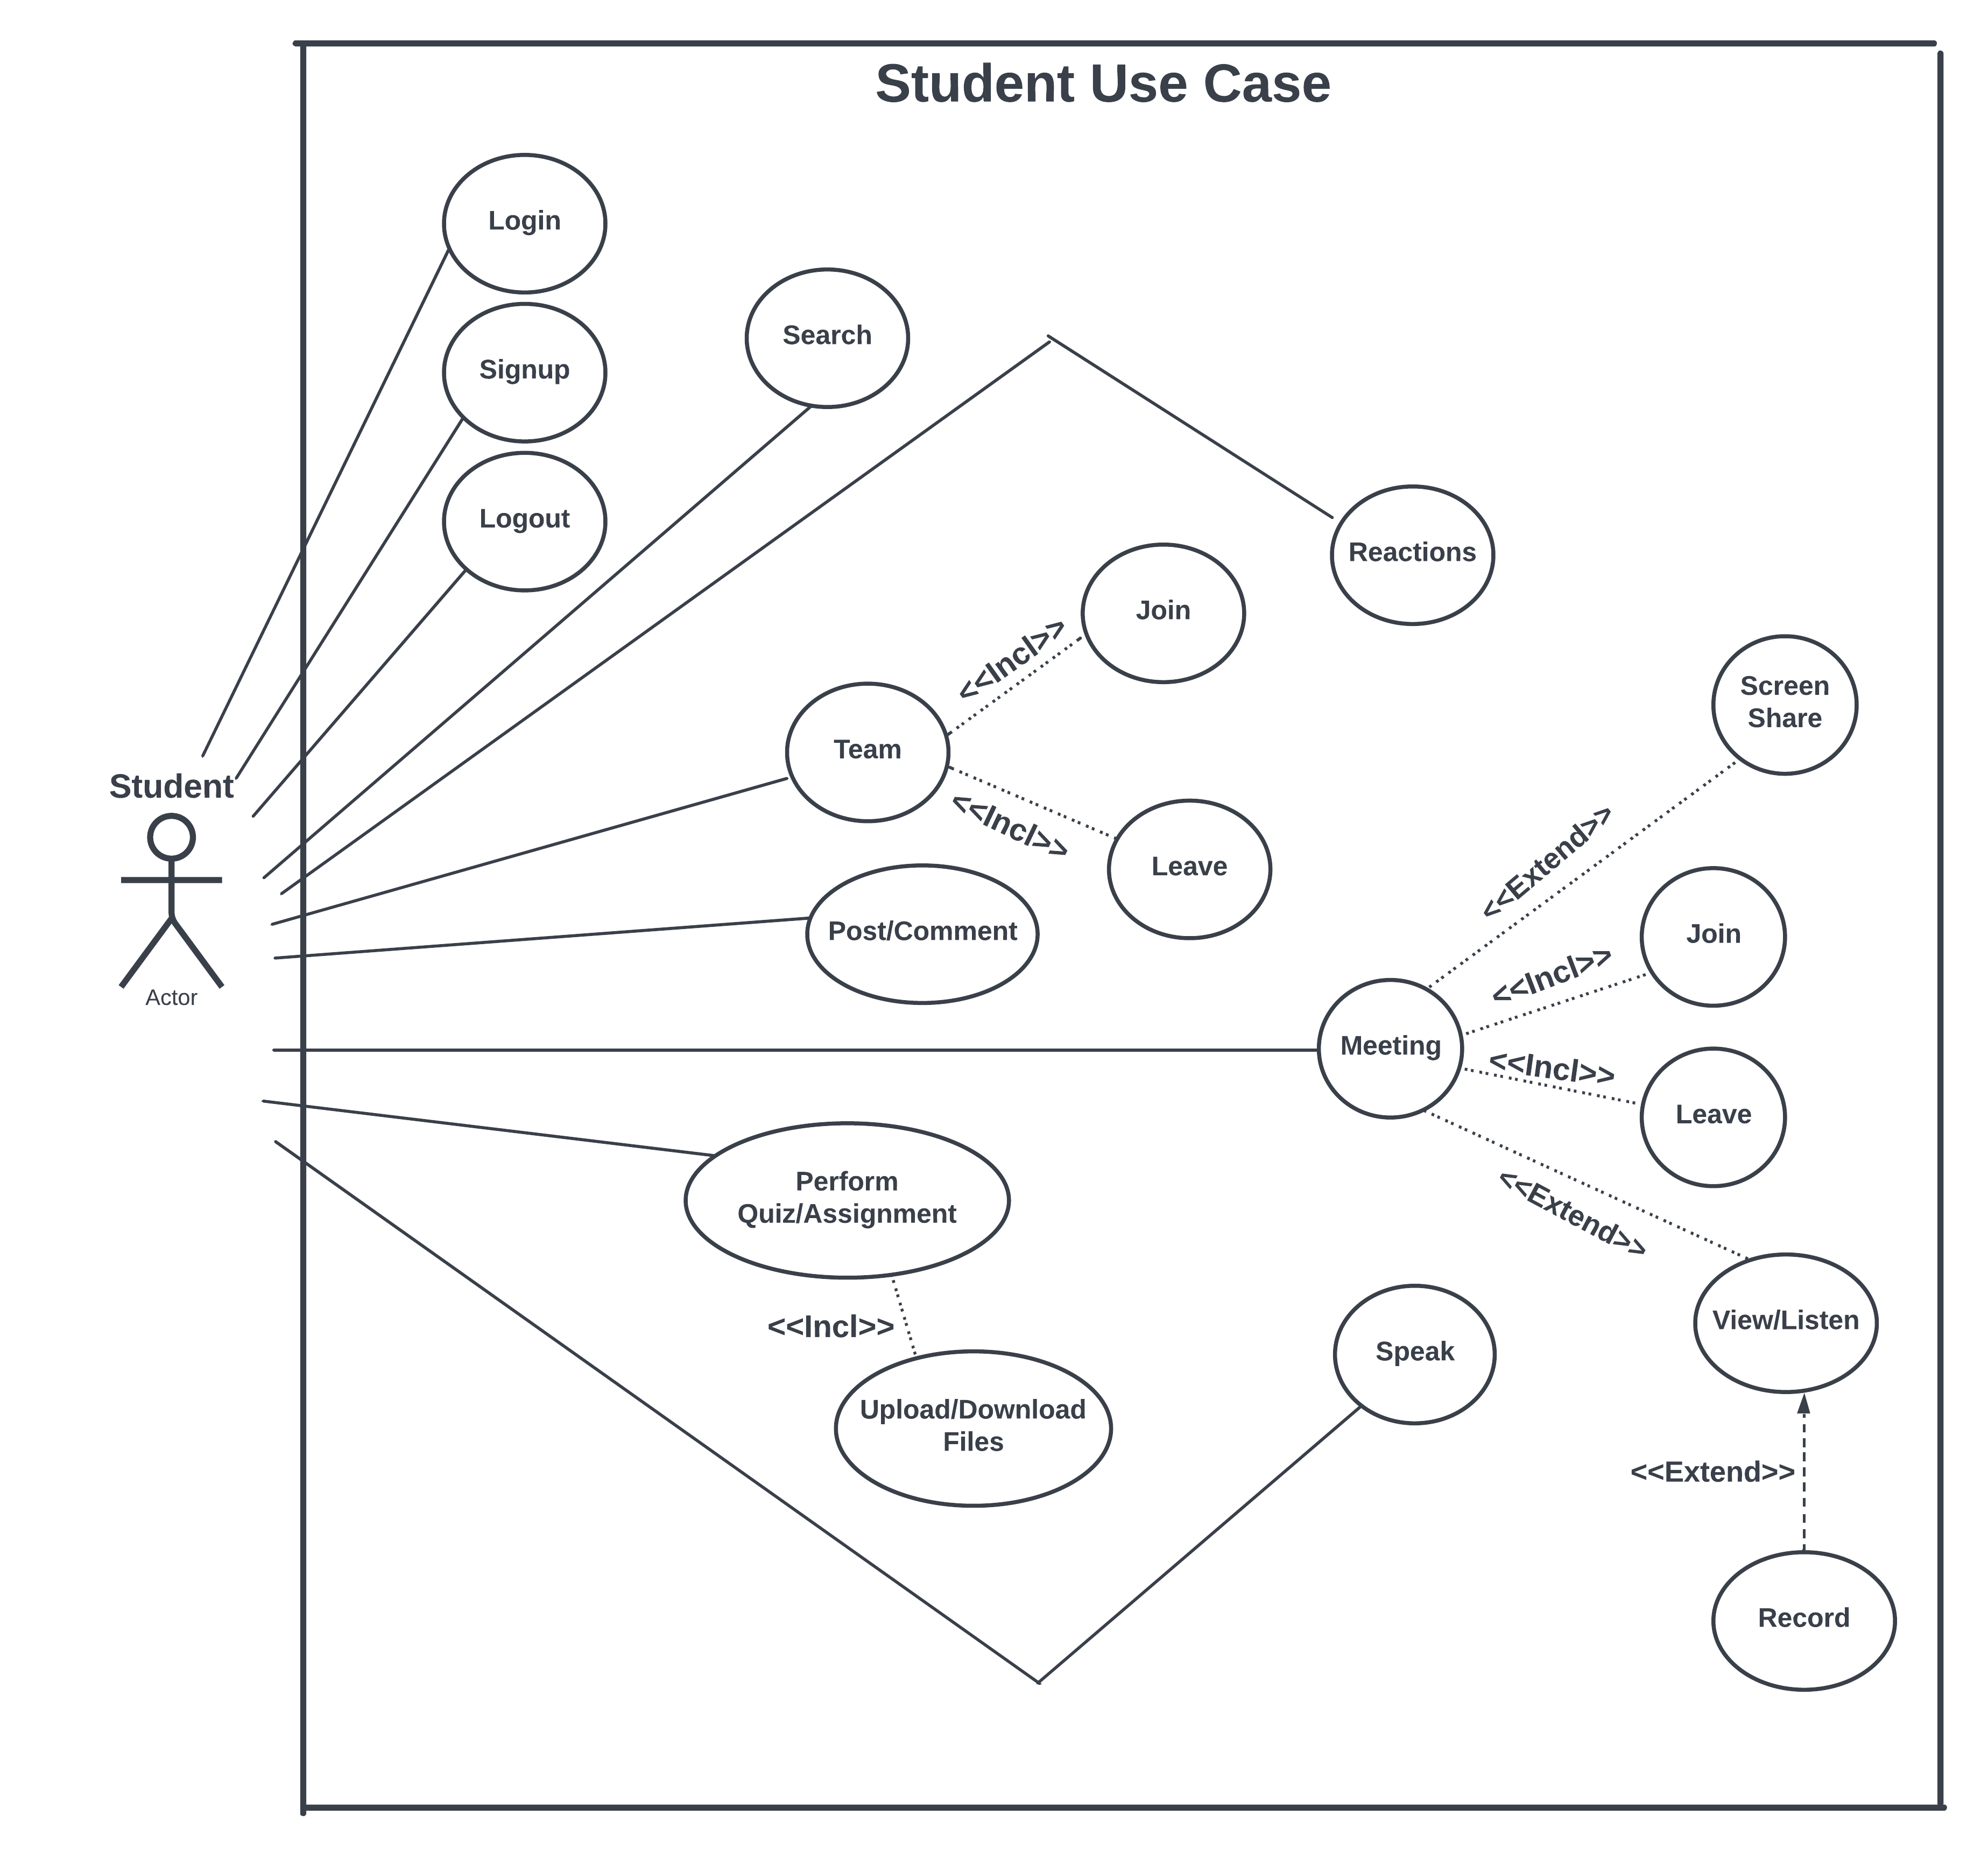

Microsoft Teams for Education offers digital collaboration solutions tailored [for universities and schools](https://edublog.microsoft.com/en-au/2020/12/were-here-to-help-you-get-back-to-school-ready-2/). The platform allows teachers, students, and parents to stay on top of remote or hybrid learning.

 This provides a collaboration platform for teachers and students to share content with a familiar look and feel to a traditional classroom. Teachers can utilize a unique OneNote feature called [Class Notebook](https://support.microsoft.com/en-us/office/use-class-notebook-in-teams-e0f77c27-155f-4d4c-83e8-c8e7e5ca9233?ui=en-us&rs=en-us&ad=us#ID0EABAAA=Students) that provides each student a private notebook that is only visible to themselves and the teacher. Students can also collaborate on OneNote pages together as they work on projects or group assignments. Additionally, the [Assignments](https://support.microsoft.com/en-us/office/assignments-and-grades-in-your-class-team-7cb294be-2c63-4f2d-acf2-299329bcd5bf?ui=en-us&rs=en-us&ad=us) feature allows teachers to both assign and grade student homework, set due dates and then students can digitally turn in these assignments and view their grades.

**USE CASES DESIGNED FOR TEACER-STUDENT RULES:**

|  |  |  |
| --- | --- | --- |
| **Use Case ID:** | UC-1 | |
| **Use Case Name:** | View Quiz | |
| **Actors:** | | Students / Teachers |
| **Description:** | | Students as well as teacher will be able to view the quiz , student for solution and teacher to mark the quiz. |
| **Trigger:** | | Quiz is available for both actors to examine. |
| **Preconditions:** | | Quiz is available for students to take and upload solution. |
| **Postconditions:** | | After solution teacher will be able to see and mark the quiz. |
| **Normal Flow:** | | 1. Actors are required to open an active team account 2. Click on assignment option 3. Click on quiz 4. Click on view quiz 5. Then actors will be able to see the quiz |
| **Alternative Flows:**  **[Alternative Flow 1 – User does not have account]** | |  |
| **Exceptions:** | | Internet connection must be fast. |
| **Includes:** | | 1. Authorize user |
| **Business Rules:** | | 1. Teacher as well as students can view 2. Can make changes in quiz 3. Students in quiz solution 4. Teachers in quiz questions |
| **Special Requirements/ Other Information:** | | 1. Proper quiz document 2. Proper quiz solution document 3. Fast Internet connection |

|  |  |
| --- | --- |
| **Use CaseID** | UC-2 |
| **Use Case Name** | Add a member. |
| **Actors** | Organizer (Teacher), Member (student). |
| **Description** | Once the team has been created by the organizer, He can add members (Students in case of educational institute). |
| **Trigger** | The team owner can press on add members while creating the team. |
| **Pre-Conditions** | 1. A team should be created. 2. Student should be registered on MS teams. 3. Stable internet connection. |
| **Post-Conditions** | 1. Member will be added. 2. Member can now access the team. |
| **Normal Flow** | 1. Teacher will create the team. 2. He will click in add member option and add members by their ID’s or emails. 3. The member will be added to the team. 4. If it’s a private team. |
| **Alternative Flow** | 1. The member will go to teams. 2. He will press on the assignment tab. 3. And there press join team by using code. 4. The He will put in the provided code. 5. The member will be added to the teams. |
| **Exceptions** | If it’s a private team:   1. The student will need to use the code to join. 2. Or will require the organizer to send the link. |

|  |  |
| --- | --- |
| **Use Case ID:** | **UC-3** |
| **Use case name:** | **Adding Group** |
| **Actors** | **New users , Old users** |
| **Description:** | Through this use case user can join, add groups through password. |
| **Actors:** | Attendees(students), organizer(teacher) |
| **Preconditions:** | 1. If user is new then first he will create his account then he can add groups. 2. If user is old then first he will login then add groups |
| **Postconditions:** | User / Actor can join groups |
| **Flow:** | 1. User will login or signup 2. Then add groups |
| **Include:** | Group password |

|  |  |
| --- | --- |
| **Use Case ID:** | **UC-4** |
| **Use case name:** | **Join meeting** |
| **Actors** | **New users , Old users** |
| **Description:** | Through this use case user can join meeting that is presenting by the teacher. |
| **Actors:** | Attendees(students), organizer(teacher) |
| **Preconditions:** | 1. If user is new then first he will create his account then he can join meeting. 2. If user is old then first he will login then join meeting. |
| **Postconditions:** | User / Actor can join groups |
| **Flow:** | 1. User will login or signup 2. Then join meeting. |
| **Include:** | Join meeting |

|  |  |
| --- | --- |
| **Use Case ID:** | **UC-5** |
| **Use Case name:** | **Uploading a file** |
| **Description:** | Microsoft provides features of uploading an assignment or file which enables the users to upload their files and then everyone can work on those files. Mainly used for uploading class assignments or other files |
| **Actors:** | Attendees(students), organizer(teacher) |
| **Preconditions:** | 1. We should have account in teams. 2. File should be saved in the memory to upload it. |
| **Postconditions:** | Once the assignment is uploaded than we can:   * Open it. * Download it. * Can make it available offline. * Can share it. * Can copy link. * Can send a copy. * Can also open in particular app. |
| **Flow:** | 1. In teams, we go to files. 2. Click the **+** option, it will show two options:  * Create a folder.  1. We can create a new folder and then upload files in it.  * Upload.  1. Can simply select a saved file from storage and then upload it. |
| **Alternative Flows:** | 5. In alternate flow, it is quite possible file may be not uploaded due to signal issues or some other software problems.  So, we should have stable connection at that time. |
| **Exceptions:** | 2. The exceptions that could occur in this use case are:   * May be teams doesn’t support that type of software in which we want to upload a file. |
| **Requirements:** | The following requirements must be met before execution of the use case:   * We must have account on teams. * We must have stable internet connection. |

|  |  |
| --- | --- |
| UseCaseID | UC-6 |
| UseCase Name | Download Attendance |
| Actors | * Organizer * Co-Organizer |
| Description | If you've organized a Teams meeting, you can download a current attendance report during the meeting as well as a final report after the meeting. The report includes the name of each person in the meeting and the time they joined and left. |
| Trigger | Organizer, Co-Organizer can download the attendance list by clicking on options button in “Participants Tab”. |
| Pre-Conditions | * Meeting should be started in order to get attendance. * The report does not include insights from deleted breakout rooms. |
| Post Conditions | * Meeting should be completed in order to get full attendance. The post-meeting report will contain the full list. |
| Normal Flow | * In Teams, go to **Calendar** * Open the meeting * Select the **Attendance**tab * You can view the data directly in Teams. * You can download it in Different forms |
| Alternative Flow | To download the attendance .CSV file for the meeting, click **Download(as CSV)**: |
| Exceptions | * The report does not currently include view-only attendees. * If someone waits in the lobby and doesn't get admitted to the meeting, they won't be included in the report. |
| Includes | * In meetings with more than 120 participants, the attendance report that's available during the meeting will only include a partial list of attendees. * When a participant is on hold in a meeting, their info is still included for this period of time in attendance report. |
| Business Rule | 1. A student is not allowed to join if is banned from class for doing unethical things. 2. Attendee is not allowed in meeting if he doesn’t meet the pre requisites. |

|  |  |
| --- | --- |
| USE CASE ID | UC- 7 |
| USE CASE NAME | Distribute and grade assignments. |
| ACTORS | Teacher |
| DESCRIPTION | Teacher will upload an assignment .Student will attempt it.Teacher will grade the assignment. |
| TRIGGER | It can be triggered from assignment tab. |
| PRECONDITION | 1. Teacher will create team 2. Teacher must have stable internet connection(so he or she can upload assignment) |
| POSTCONDITION | 1. Content of assignment will be delivered 2. Grade will be displayed to students after deadline. |
| NORMAL FLOW | For Assignment Distribution   1. Select teams 2. Navigate to the desired class team,then select Assignment. 3. Select Create>Assignment. 4. Enter a title for Assignment. 5. Add instructions(due date etc). 6. Select channel for the assignment notification. 7. Select assign at the top to assign work.   For Grading   1. Select teams 2. Navigate to your class team and select assignment. 3. Select create>assignment. 4. Select add rubric>+Add rubric ,this will open rubric creator. 5. Add title,description and turn on points if you like to assign points values to your grading criteria. |
| EXCEPTIONS | If there were some connection issues;   1. System will ask teacher to check his connection. 2. Teacher must reconnect his device to the internet. 3. After reconnection use cases will resume. |
| QUALITY REQUIREMENTS | 1. To receive assignment the student should be registered on teams. 2. Assignment should be available on team till deadline. |
| BUSINESS RULE | 1. Assignment will be removed after the deadline. 2. Assignment will be only available to team members. |

|  |  |
| --- | --- |
| USE CASE ID | UC- 8 |
| USE CASE NAME | Ask question |
| ACTORS | New users, old users |
| DESCRIPTION | Through this use case, students can ask questions from teachers about the lecture |
| PRE-CONDITION | If user is new then he will create account then he can join the meeting and can ask questions. But if the user is old, he will login first then join the meeting and can ask questions. |
| NORMAL FLOW | If user want to ask question then he will follow these steps.   1. Create account or login 2. Join meeting 3. Then can ask question |
| INCLUDE | By opening mic and camera |

**____________________________________________**